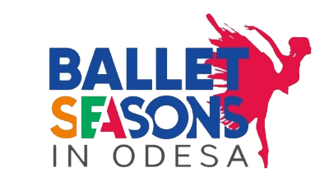
Participation - The ІІІ International Competition of Choreographic Art memory E. Karavaeva "Вallet season in Odessa"
Dates - 17.04.2021 -18.04.2021 y/y
Warning! Due to restrictions on cultural events related to the coronary virus pandemic (COVID-19) in 2021, the competition will be held remotely.
(The application is filled in each part separately: on the teams at the soloists and in the small-form)

TITLE OF THE COMPETITION | The First International Competition of Choreographic Art memory E. Karavaeva "Вallet season in Odessa"
Period | 17.04.2021 -18.04.2021
The full name of the group
Address, phone, fax, e-mail
Name and surname of the head
List of art directors names
Nomination:
Classical..dance: -Solo; -Small forms (2-7 pers.); -groups (from 8 pers.).
Modern//choreography: -Solo; -small form (2-7 pers.); - Groups (from 8 pers.).
Additional nominations:
Classical..dance: -Solo; -Small forms (2-7 pers.); -groups (from 8 pers.).
Modern//choreography: -Solo; -small form (2-7 pers.); - Groups (from 8 pers.).
Age group:

I (junior) - 8-10 years;
II (medium) - 11-13 years;
III (senior) - 14-16 years;
IV (adult) - 17-19 years;
Mixed (collective)
Number of people
The number of people acting
Number of accompanying
Spoken language group
Brief description of the group (year of education, awards, performances)
Performance program (title number, time of execution)  Room with a first round (video-selection may also be present) | 1 st Room  ___________________________________________________________________________________  No. Name (song, dance)  ________________________________________________________________________________________  (Author of text, music, performances, time.)  2 st Room  ________________________________________________________________________________________  No. Name (song, dance)  _______________________________________________________________________________________  (Author of text, music, performances, time.)
Number of soloists in the group, their names, and the names and surnames of teachers
Number of duets in the group their first and last names, as well as the names and surnames of teachers
Small form (up to 5 persons) in the group their first and last names, as well as the names and surnames of teachers
How do you know about us?
What technical assistance is needed for the execution of the program.

LIST OF PERSONS ON you need to prepare a thank you letter (not more than 2).
* Please specify all data as they appear in the passport.
№ | Name and  Last Name | Position / Sponsor | Organizations | Thanks for the ...
1
2

ATTENTION!
Letters of thanks and certificates shall be drawn up on the basis of data received from you, please send the correct data because any changes in the period of the competition are not allowed.

ATTENTION!
Prerequisite for participation in the are:
1. I round of the competition - qualifying - held on the video with the performance of a choreographic numbers, which should be sent to the email address of the contest shkola-balet@ukr.net. 2. As a result of the selection of the video for the second round of the competition will be sent details of the enrollment fee, and after confirmation of payment - an official invitation to the competition.
3. Your music is necessary to provide a Flash-Drive.
Teams and soloists that not follow the rools will not be allowed to participate in the international competition. .
Applications send to shkola-balet@ukr.net.

