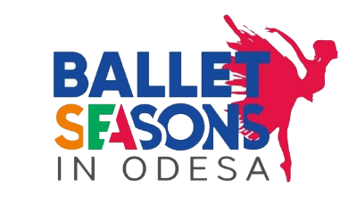
III International Competition of Choreographic Art in Memory of E. Karavaieva
"Ballet seasons in Odesa"
17.04.2021-18.04.2021
Warning! Due to restrictions on cultural events related to the coronary virus pandemic (COVID-19) in 2021, the competition will be held remotely.

REGISTRATION

Competition name
Contest period
Name and last name
Age categories
І (junior) - 8-10 years
II (middle) - 11-13 years
III (senior) - 14-16 years
IV (adult) - 17-19 years;
Phone Number
Email
First and last name of the manager

Artistic directors names
-Nomination (Classical dance)
-Nomination (Modern choreography)
-Performance program (name, time of the performance) - Variation 1

-Performance program (name, time of the performance) - Variation 2
Additional Information
Number of accompanying persons
What technical assistance is needed?

